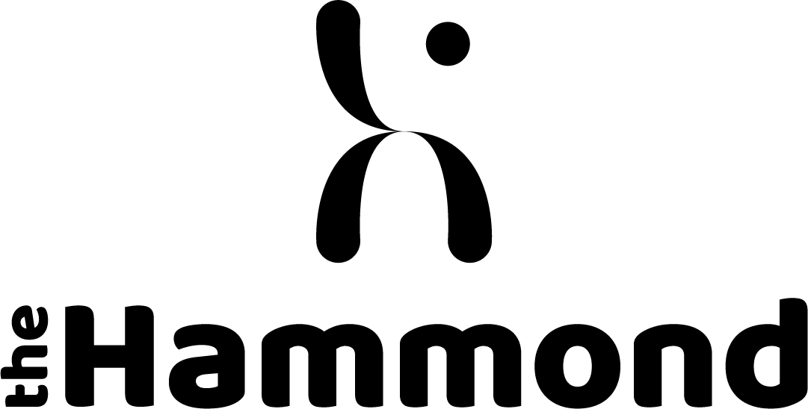
The Hammond School
GCSE Results
2023

 | No. of entries | 9 | 8 | 7 | 6 | 5 | 4 | 3 | 2 | 1
English Language | 29 | 2 | 0 | 2 | 10 | 10 | 4 | 0 | 0 | 1
English Literature IGCSE (taken in 2022) | 29 | 2 | 4 | 9 | 3 | 8 | 3 | 0 | 0 | 0
Mathematics | 29 | 0 | 1 | 3 | 4 | 6 | 13 | 0 | 2 | 0
Science Trilogy* combined | 29 | 1 | 1 | 2 | 5 | 8 | 9 | 3 | 0 | 0
Art | 2 | 0 | 0 | 0 | 6 | 0 | 0 | 0 | 0 | 0
Business studies | 5 | 0 | 0 | 1 | 1 | 1 | 0 | 2 | 0 | 0
French | 12 | 1 | 1 | 1 | 1 | 2 | 3 | 3 | 0 | 0
Geography | 5 | 0 | 0 | 0 | 2 | 1 | 2 | 0 | 0 | 0
History | 10 | 1 | 0 | 1 | 5 | 1 | 0 | 2 | 0 | 0
Music | 17 | 1 | 3 | 0 | 3 | 6 | 4 | 0 | 0 | 0
Drama | 19 | 0 | 5 | 5 | 6 | 2 | 1 | 0 | 0 | 0
English Literature IGCSE (Y10) | 30 | 0 | 4 | 4 | 3 | 9 | 7 | 3 | 0 | 0
LEVEL 2 Certificate in Creative & Performing Arts
 | No. of entries | D* | D | M | P | L1
 | 8 | 0 | 8 | 0 | 0 | 0

